Chapter 9, Solution 80.

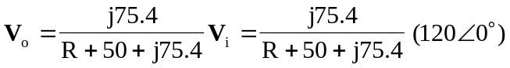

- When 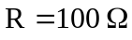,
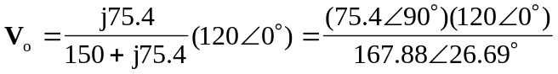
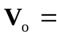 53.8963.31 V

- When 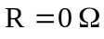,
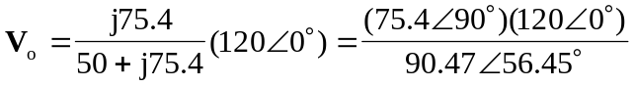
10033.55 V

- To produce a phase shift of 45, the phase of 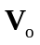 = 90 + 0   = 45.
Hence,  = phase of (R + 50 + j75.4) = 45.
For  to be 45, R + 50 = 75.4
Therefore, R = 25.4 

